**Resources**

[Current PSE-C Portal](https://store.usps.com/store/pse/)

* Will need usps.com PROD account to access. Not many tool tips listed here but there are some.

[New PSE-C Prototype](https://www.figma.com/proto/mf9OcoWFZVm1RJyAKy90UB/PSC-E?node-id=0-1&fuid=1334141827828563262)

* These are the Figma files of the PSE/C Redesign with expanded tool tips.

**New PSE-C Tool Tips for Review**

**Personalized Stamped Envelopes**

* **Select Envelope Type:** Choose the appropriate envelope for your document. The options are:
  + **Plain Envelope**: A standard envelope with no window, ideal for general use.
  + **Envelope with Window**: A standard envelope with a transparent window for displaying addresses on pre-printed forms or invoices.

* **Select a Closure Type:** Choose between **Self-Stick Adhesive** for a quick and easy seal with no moisture needed, or **Water-Activated Adhesive** for a secure seal that requires a small amount of water to seal.

* **Select a Stamp:** A Forever® stamp covers postage for up to 1 oz and is always valid at the current Forever stamp value.

* **Choose a Format:** Select the number of envelopes you need.

* **Add Return Address:** Enter your return address that will appear on the envelope. This ensures that undelivered mail can be returned to you.
* **Address Source:** Enter the destination address for your mail. You can select from your USPS® address book or enter it manually.

* **If your letter can’t be delivered, want it returned quickly?**

**What is a Retention Period?**

Retention periods tell the Postal Service how long to hold mail that can’t be delivered before returning it to you. In general, mail is held for 15 days before returning it. You can choose to have it returned after 3, 5, 7, or 10 days.

**Note**: Adding a retention period endorsement reduces the number of address lines available (maximum of 7 lines).

* **Want to request ancillary services?**

**What are Ancillary Services?**

**Return Service Requested**: Undeliverable mail is returned to you at no charge with the recipient’s new address or the reason for non-delivery.

**Temp-Return Service Requested**: Mail is forwarded at no charge if the recipient files a temporary address change. No notification provided.

**Address Service Requested:**

* + - *For 12 Months*: Mail is forwarded, and you receive the recipient’s new address. Address correction fee applies.
    - *For Months 13-18*: Mail is returned with the new address. No charge.
    - *After 18 months*: Mail is returned with a reason for non-delivery. No charge.

**Change Service Requested:** You receive notification of the recipient’s new address or the reason for non-delivery. Address correction fee applies. The mail is discarded or recycled.

**Forwarding Service Requested:**

* + - *For 12 Months:* Mail is forwarded at no charge.
    - *For Months 13-18:* Mail is returned with the recipient’s new address at no charge.
    - *After 18 months:* Mail is returned with a reason for non-delivery at no charge.

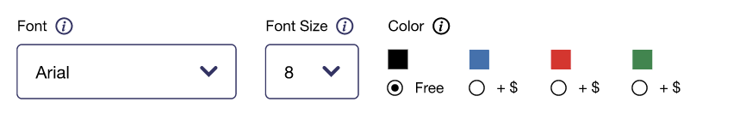

* **Font**: Select the font for the text printed on your envelope. Make sure the font can be read and fits within the space for the recipient’s address, return address, and other details.
* **Font Size:** Choose the font size for the text printed on your envelope. Ensure the size is legible and fits within the designated areas.
* **Color:** Select the color for the text printed on your postcard.

* **Special Characters:** Select a special character from the menu below to insert it into the field.

* **Get Help With This Process:** Need assistance? [Submit a request](https://emailus.usps.com/s/the-postal-store-inquiry) to the Customer Service Center.

**Personalized Stamped Postcards**

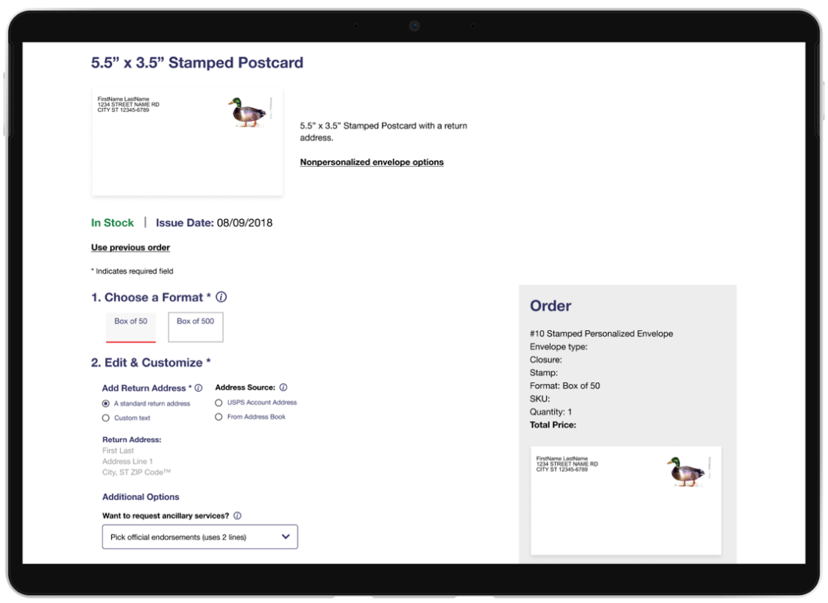

* **Choose a Format:** Select the number of postcards you need.

**[No Image]**

* **Select a Stamp:** The Mallard Stamp is a Forever® stamp that covers postage for one postcard and is always valid for the current postcard stamp value.

* **Add Return Address:** Enter your return address that will appear on the postcard. This ensures that undelivered mail can be returned to you.
* **Address Source:** Enter the destination address for your postcard. You can select from your USPS® address book or enter it manually.

* **Want to request ancillary services?**

**What are Ancillary Services?**

**Return Service Requested**: Undeliverable mail is returned to you at no charge with the recipient’s new address or the reason for non-delivery.

**Temp-Return Service Requested**: Mail is forwarded at no charge if the recipient files a temporary address change. No notification provided.

**Address Service Requested:**

* + - *For 12 Months*: Mail is forwarded, and you receive the recipient’s new address. Address correction fee applies.
    - *For Months 13-18*: Mail is returned with the new address. No charge.
    - *After 18 months*: Mail is returned with a reason for non-delivery. No charge.

**Change Service Requested:** You receive notification of the recipient’s new address or the reason for non-delivery. Address correction fee applies. The mail is discarded or recycled.

**Forwarding Service Requested:**

* + - *For 12 Months:* Mail is forwarded at no charge.
    - *For Months 13-18:* Mail is returned with the recipient’s new address at no charge.
    - *After 18 months:* Mail is returned with a reason for non-delivery at no charge.

* **Font:** The text on your postcard will be printed in Arial font.
* **Font Size:** The text size on your postcard will be size 8.
* **Color:** The text on your postcard will be black.

* **Special Characters:** Select a special character from the menu below to insert it into the field.

* **Get Help With This Process:** Need assistance? [Submit a request](https://emailus.usps.com/s/the-postal-store-inquiry) to the Customer Service Center.